|  |  |
| --- | --- |
| Team ID | PNT2022TMID16931 |
| Project Name | Project – News Tracker Application |
| Maximum Marks | 8 Marks |

**SETTING UP APPLICATION ENVIRONMENT**

**DOCKER CLI NSTALLATION**

**Step 1**. Download Docker from docker.com and install it by running the Docker Desktop Installer.exe file.

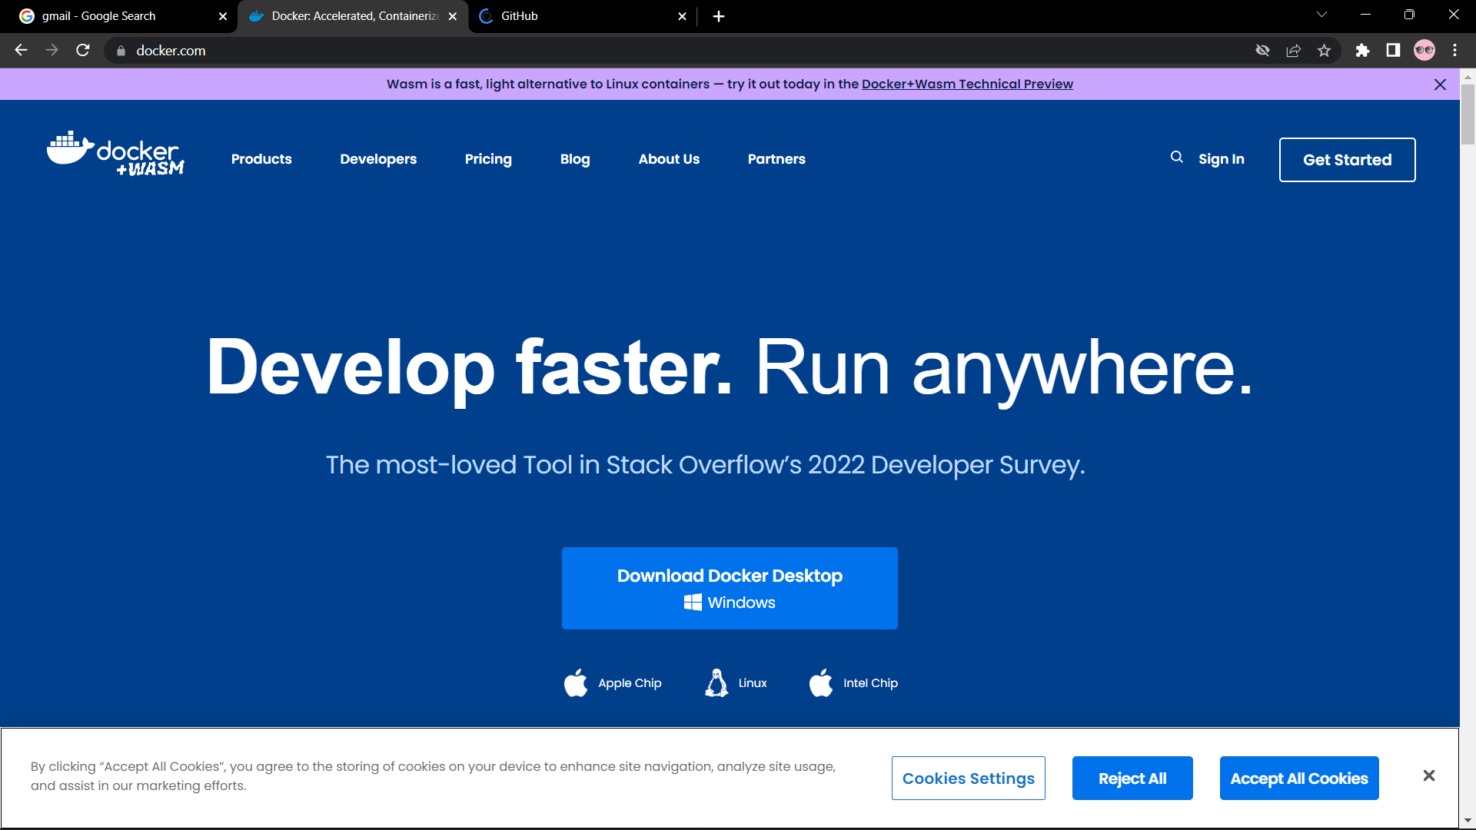

# **Step 2**. Goto hub.docker.com register and create an account and login with the same.

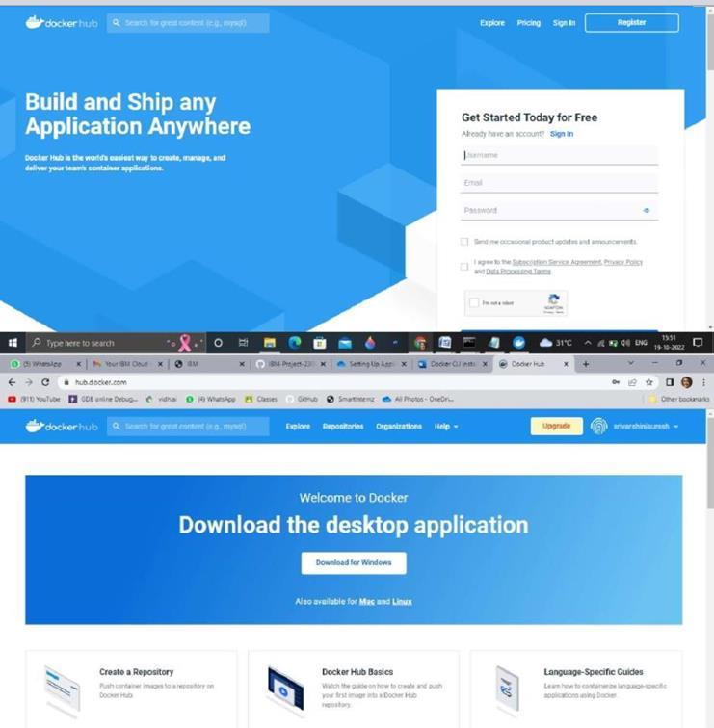

# **Step 3**. Open Docker Desktop and start creating containers and images

